**CLOUD BASED BUSS PASS SYSTEM**

# SAKSHAM JOHRI, AAYUSHI RAI, PRANJUL SINGHAL

*(Student, Cloud Computing and Virtualization)*

---------------------------------------------------------------------***---------------------------------------------------------------------

**Abstract** *- As the urban living environment is becoming more and more complex, the road condition is becoming worse because of heavy traffic, an increase in traffic, accidents and the high ratio of empty buses. It increases the cost of transportation and wastes time of bus movement. So in this application, we track the Bus and send data to the server for user usage. To solve such problems, we have developed land bus tracking system and QR Code based ticket pass system. A bus tracking system determines the position of the bus using conductor phone via GPS and displays the position on a digital map. This application has many real-time applications in real world. Using this application user can track the PMT bus. Also, he can set the reminder for the specific bus so he can know that bus arrives at the stop or not. Also, he can know the nearest stop to pick up the bus. Also, the user can online apply for the bus pass and get QR Code as like bus pass. The conductor only scans QR Code and Reduce One Day (one way) traveling fare from passenger account. The conductor can verify passenger on the basis of registered Photo. Using this application Show Shortest Path wise Bus and Fare of Source to the destination, Show Next Stop Details and Calculate time and also Notify user when Bus Near By Last Stop.*

***Key Words: GPS, Bus Tracking, Reminder, Cellular Tower, Show Shortest path, QR Code***

# INTRODUCTION

In today's computing world, different technologies have emerged. These have grown to support the existing computer networks all over the world. With mobile computing, we find that the need to be conned within one physical location has been eradicated. We hear of terms such as telecommuting, which is being able to work from home or the field but at the same time accessing resources as if one is in the office. In the certain metropolitan area, the road condition is becoming worse because of heavy traffic and it increases the traffic accidents and the high ratio of empty buses. It increases the cost of transportation and wastes time of bus movement. So this application will helpful for tracking of the Bus which gives the exact time of the bus arrival so that passengers need not wait at bus stops for buses. This application can be used to give the information to the passenger about real-time bus arrival time information under Indian traffic conditions. Show It also provide shortest path wise Bus And Fare of

Source to the destination, also Show Next Stop Details and Calculate time. It notifies the user when the bus is nearby. a user can online apply for the bus pass and get QR Code as like bus pass. The conductor only scans QR Code and Reduce One Day (one way) travelling fare from passenger account. The conductor can verify passenger on the basis of registered Photo. The user can pay money using android apps and get renew QR Code with the New expiry date.

# RELATED WORK

The Android application uses Global Positioning System to detect passenger travelling from any source to any destination. It can help the governmental organization to identify thefts, robbers travelling through trains or metros. Map-matching [1][2] algorithms attempt to pinpoint the vehicle in a particular roadmap segment in spite of the digital map errors and navigation system inaccuracies. An asynchronous multi obstacle multi-sensor tracking method[3] that fuses information from radar and monocular vision. A low-level fusion method is integrated into the framework of an IMMPDA Kalman filter.

An android application in which ticket can carry in the form of QR code[4] but it is difficult for the passenger to understand the buying ticket is correct or not. Because most of the people are unaware of QR - Code technology.

A system that enables the use of phones for acquiring electronic public transport ticket. QR codes and RFID tags [5] are used for registering passenger at the beginning and at the end of their journeys. Use of NFC and QR code identification in an electronic ticket system for public transport.

# PROPOSED SYSTEM

We have developed land bus tracking system and QR Code based ticket pass system for tracking of the buses that determines the position of the bus using conductor phone via GPS and displays the position on a digital map.

Figure The figure shows the architecture diagram of the proposed system. The main role performed by the Admin, Passenger, and Conductor User can search bus from source to destination.

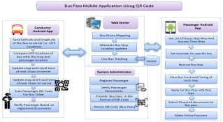

**Fig-1:** Architecture Diagram

User android automatically takes a current location through using mobile GPS. Also, the user can enter source and destination locations for bus searching. We can track the location of the bus using conductor android phones GPS device. The Bus and the phone is mapped using IMEI number. We will be pre-defining the route of each bus through a web- based application. Each bus and the conductor android device will be mapped using an IMEI number of the phone. 1 IMEI corresponds to 1 bus that is being tracked. We find the shortest path from source to destination and also calculate travelling fare. The user can choose bus which is fusible for that and also tracks it. When the bus arrives in last stop then the system automatically notify to passengers. When a stop comes we can intimate the people sitting on the bus to come in front for their stop.

The passenger can apply for bus ticket passes using android apps and submit required documents. Types of Passes:

* 1. for Children
  2. for Senior Citizen
  3. for Student etc.

When the passenger will pay some money for ticket pass then system administrator will give a one unique QR Code, it's for the first time. If the passenger had a QR Code then system administrator will change expiry date of passenger Pass. Each pass has a bus pass type like the pass for children, pass for a student, and pass for Senior citizen and so on. The conductor can scan QR Code and verify passenger on the basis of a registered photo and some documents which are verified by the system administrator. 1 QR Code has 1 Unique Passenger Id so we can find particular passenger details using QR Code.



**Fig - 2:** QR Code

QR code in our card to fetch the information of the user like username, source, destination, DOB, expiry date etc. In this application, the user has to create his profile by registering and the user will be able to make payment, for his pass.

Users can also set the reminder. For example, if the user having other work or they are working so, in that case, they can set the reminder in the application of any nearby stop and as soon as bus stop then they will get the notification on their mobile. Using this they don't have to wait for the bus and leave the work area to reach bus stop in time.

# 3. EXPERIMENTAL RESULTS

The QR Code based ticket pass system for tracking of the buses that determines the position of the bus using conductor phone via GPS.

# Registration Module

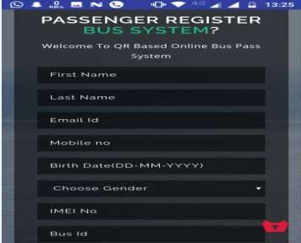

**Fig -3:** Registration

To get online digital bus pass user have to go through registration procedure for that user have to visit the site where user have to fill registration form. In registration user have to give complete details about him/her to create a new account.

## Authentication Module

After registration, user login to system by using their unique id and password. If id and password is correct than only he/she will be able to access the system.

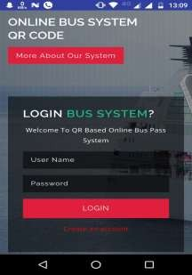 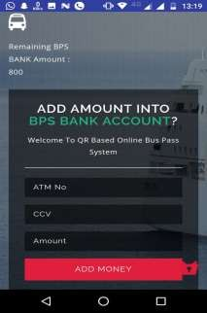

**Fig - 4:** Login Page

# Apply For Bus Pass

User can apply for bus pass with his daily route.

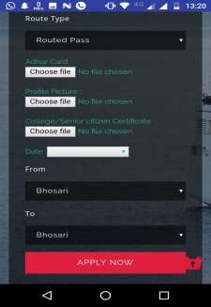

**Fig - 5:** Apply For Pass

## Payment Mode

This system provides online payment facility i.e. travelling fare is deducted from user account.

**Fig - 6:** Add Money

## D. Regular Passenger QR Code

For regular passenger the QR code is used. After scanning the QR code having all details about the user and travelling cost is deducted from users account.

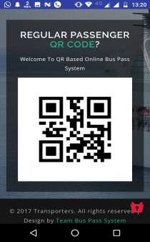

**Fig - 7:** Regular Passenger QR Code

User can search for shortest path from source to destination.

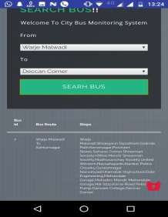

**Fig - 8:** Search Bus

The current position of the bus can be updated on the server continuously through drivers app. So that we can track the bus and know the exact time when bus comes to the nearest stop.

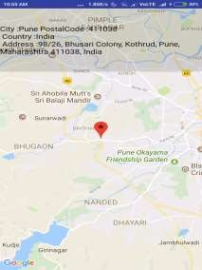

**Fig - 9:** Driver App

# CONCLUSIONS

We proposed a system i.e. the Bus pass ticketing system for providing all the details regarding bus arrival time, Time to reach to the next stop with shortest path and the nearest stop to pick up the bus which can reduce the hourly waiting of the passengers at the bus stops.. Finally, we provide the Also user can online QR Code like the bus passes. So that user doesn't have to carry the cash while travelling. The conductor only scans the pass and the travelling amount is deducted from users account.

# REFERENCES

1. J.S. Pyo, D.H. Shin, and T.K. Sung. Development of a map matching method using the multiple hypothesistechnique. Intelligent Transporta- tion Systems, 2001. Proceedings. 2001 IEEE, pages 23-27, 2001.
2. Agung Dewandaru, Abas M. Said and Abdul Nasir Matori. (2007), A Novel Map-matching Algorithm to Improve Vehicle Tracking System Accuracy.
3. Yafeng Lu, Michael Steptoe, Sarah Burke, Hong Wang, Jiun-Yi Tsai, Hasan Davulcu, Douglas Montgomery, Steven R. Corman, Ross Maciejewski, Senior Member, IEEE"Exploring Evolving Media Discourse Through Event Cueing"IEEE TRANSACTIONS ON VISUALIZATION AND COMPUTER GRAPHICS, VOL. 22, NO. 1, JANUARY 2016.
4. Feng Liu, Jan Sparbert and Christoph Stiller. (2008), IMMPDA Vehi- cle Tracking System using Asynchronous Sensor Fusion of Radar and Vision.
5. Sadaf Sheikh, Gayatri Shinde, Mayuri Potghan, T azeen Shaikh , ―Urban railway ticketing application‖ , International Journal Of Advance Research In Computer Science And Software Engineering Vol. 4, Issue 1 .
6. A. F. de Azevedo Figueiredo Cruz, ―Nfc and mobile pay ments today‖, november 2011, last visited on January 19th 2012. . Available: <http://www.di.fc.ul.pt/nuno/THESIS/AndreCruz> MSIT11.pdf .